<https://github.com/nandhinisrini04/capstone>

**Question 3:**

Implement using POSTMAN API Automation

**Scenario 1:**

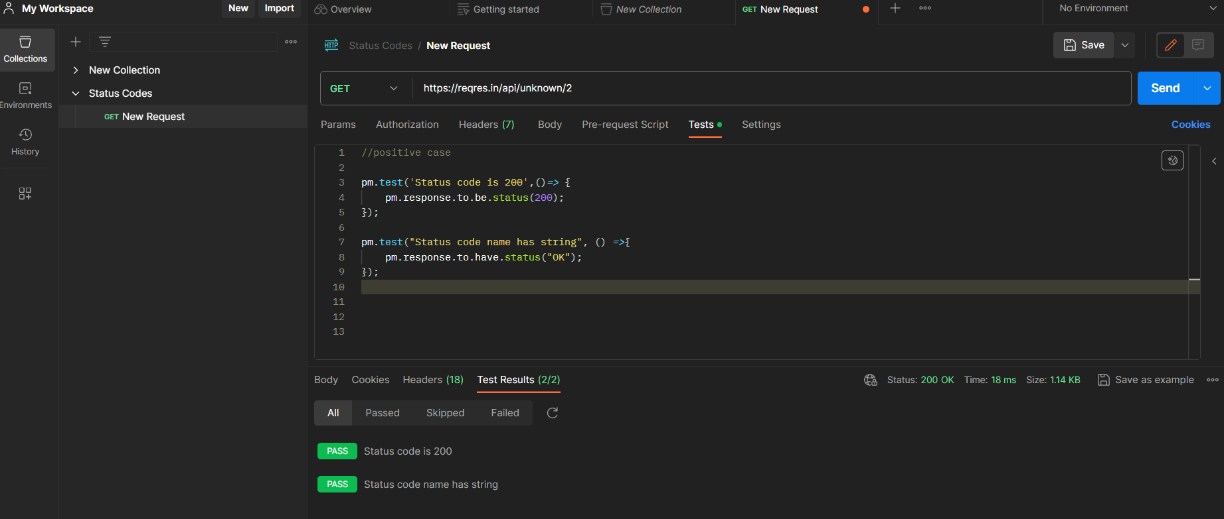

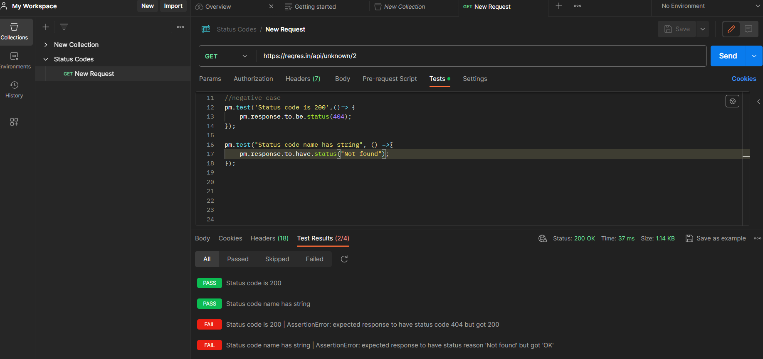

**Scenario 2:**

